**An Automatic Garbage Classification System Based on Deep Learning**

**A Project Work (CS801PC)**

**Submitted**

in partial fulfillment of the requirements for

the award of the degree of

**Bachelor of Technology**

in

**Computer Science and Engineering**

by

**Ms. ALUGUBELLY POORNIMA (17261A05C1)**

Under the Guidance of

**Mr. P. SATYA SHEKAR VARMA**

**(Assistant Professor)**



**Dept. of Computer Science and Engineering**

**MAHATMA GANDHI INSTITUTE OF TECHNOLOGY**

**HYDERABAD - 500075**

MAHATMA GANDHI INSTITUTE OF TECHNOLOGY

(Affiliated to Jawaharlal Nehru Technological University Hyderabad)

Gandipet, Hyderabad - 500075, Telangana.

**Certificate**



This is to certify that the thesis entitled **Content Based Image Retrieval System** is being submitted by **Ms. Alugubelly Poornima** bearing roll no:**17261A05C1** in partial fulfillment for the award of **Bachelor of Technology** in **Computer Science and** **Engineering** to **Jawaharlal Nehru Technological University Hyderabad** is a record ofbonafide work carried out by her under our guidance and supervision.

Guide Head of the Department

**Mr. P. Satya Shekar Varma** **Dr. C.R.K. Reddy**

Asst. Professor Professor

**External Examiner**

i

**Declaration**

This is to certify that the work reported in this project titled “**Content Based Image Retrieval System”** is a record of work done by me inthe Department of Computer Science and Engineering, Mahatma Gandhi Institute of Technology, Hyderabad.

No part of the work is copied from books/journals/internet and wherever the portion is taken, the same has been duly referred in the text. This report is based on the work done entirely by me and not copied from any other source.

The results embodied in this project have not been submitted to any other university or Institute for the award of any degree or diploma.

**ALUGUBELLY POORNIMA**

**H.T. No:17261A05C1**

ii

**Acknowledgement**

The satisfaction that accompanies the successful completion of any task would be incomplete without the mention of people who made it possible because success is the abstract of hard work and perseverance, but steadfast of all is encouraging guidance. So, I acknowledge all those whose guidance and encouragement served as a beacon light and crowned my efforts with success.

I would like to express my sincere thanks to my guide **Mr. P. Satya Shekar Varma**, **Assistant Professor**, Department of CSE, MGIT, for his constant guidance, encouragement andmoral support throughout the project.

I am extremely thankful to **Dr. M. Rama Bai, Professor** and **Dr. V. Subba Ramaiah, Sr. Assistant Professor**, Department of CSE, Major Project Coordinators, MGIT, for their encouragement andsupport throughout the project.

I convey my heartfelt thanks to **Dr. C.R.K Reddy**, **Professor & HOD**, Department of Computer Science and Engineering, MGIT, for all the timely support and valuable suggestions during the period of project.

I am also thankful to **Dr. K. Jaya Sankar, Principal MGIT**, for providing the work facilities in the college.

Finally, I would like to thank all the faculty and staff of CSE Department who helped me directly or indirectly, for completing this project.

**ALUGUBELLY POORNIMA**

**H.T. No:17261A05C1**

iii

|  |  |  |  |  |
| --- | --- | --- | --- | --- |
|  |  | | **Table of contents** |  |
|  | Certificate | | | i |
|  | Declaration | | | ii |
|  | Acknowledgement | | | iii |
|  | List of Figures | | | vi |
|  | List of Tables | | | vii |
|  | Abstract | | | viii |
| **1.** | **Introduction** | | | **1** |
|  | 1.1 | | Problem Definition | 1 |
|  | 1.2 | | Project Scope | 1 |
|  | 1.3 | | Existing System | 2 |
|  | 1.4 | | Proposed System | 2 |
|  | 1.5 | | Requirements Specification | 3 |
|  |  | | 1.5.1 Software Requirements |  |
|  |  | | 1.5.2 Hardware Requirements |  |
|  | 1.6 | | Software Tools Used | 3 |
|  |  | | 1.6.1 Python | 3 |
|  |  | | 1.6.2 Jupyter Notebook | 4 |
|  |  | | 1.6.3 VSCode | 4 |
| **2.** | **Literature Survey** | | | **5** |
| **3.** | **Methodology** | | | **7** |
|  | 3.1 | | Analysis of Dataset | 7 |
|  | 3.2 | | System Architecture | 8 |
|  | 3.3 | | Convolutional Neural Networks | 8 |
|  | 3.4 | | VGG19 Model | 11 |
| **4.** | **Implementation and Results** | | | **12** |
|  | 4.1 | | How to run the project | 12 |
|  | 4.2 | | Output Screens | 13 |
| **5.** | | **Conclusion and Future Scope** | | **18** |
|  | 5.1 | | Conclusion | 18 |
|  | 5.2 | | Future Scope | 18 |
|  | **Bibliography** | | | **19** |
|  | **Appendix** | | | **20** |

# ABSTRACT

Garbage classification has always been an important issue in environmental protection, resource recycling and social livelihood. In order to improve the ef_ciency of front-end garbage collection, an automatic garbage classification system is proposed based on deep learning. Firstly, the overall system of the garbage bin is designed, including the hardware structure and the mobile app. Secondly, the proposed garbage classification algorithm is based on ResNet-34 algorithm, and its network structure is further optimized by three aspects, including the multi feature fusion of input images, the feature reuse of the residual unit, and the design of a new activation function. Finally, the superiority of the proposed classification algorithm is veri_ed with the constructed garbage data. The classification accuracy of the proposed algorithm is enhanced by 1.01%. The experimental results show that the classification accuracy is as high as 99%, the classification cycle of the system is as quick as 0.95 s.

# 1.INTRODUCTION

Therefore, the ef_ciency of the garbage classification still needs to be improved. It is of great academic value and practical signif-icance to study an effective automatic garbage classification method. For the commercialization of intelligent garbage bin, there are some attempts made by foreign companies, such as NAS-TAR in the United States, Zeton, and the Japanese somatosen-sory intelligent garbage bin. There are a lot of researches on the intelligence garbage bin in academia. Kano *et al.* [8] proposed a group-control robot system, which provides a The associate editor coordinating the review of this manuscript and approving it for publication was Chao Shen . decentralized control scheme for indoor garbage collection.But it depends on the cooperation between robots and takes a long time. Wesley *et al.* [9] proposed low-cost intelligence garbage bin. It optimized the treatment of waste by taking the capacitance and spectrum of waste as the classification standard. However, this method is highly dependent on the

surrounding environment, its classification still has limita- tions. The research of garbage classification system is mature,but the accuracy and speed of garbage classification still needto be improved. And there are few researches on garbage classification based on deep learning. At present, deep learn-ing technology is widely used in image classification, and has some remarkable achievements. ResNet proposed by He *et al.* [10] achieved an accuracy of 93.03% and 95.51% on cifar-10 and Imagenet respectively. Zhong *et al.* [11] com- bined residual and Inception blocks, achieved the accuracy of 99.66%, 98.04%, and 95.32% on MNIST, SVHN, and cifar-10, respectively. In the public data set, using deep learn- ing algorithm can get high classification accuracy, which still can be improved. It also provides a new idea for the research of garbage classification. With the rapid development of arti_cial intelligence, image classification algorithms are gradually diversi_ed. The mainstream algorithms are AlexNet, VGG, Inception and ResNet. Scholars implemented experiments using these methods and made attempts to modify in order to gain bet-

ter results [12]_[17]. These are helpful for the improve- ment of network structure in this paper. Thanks to the nonlinear characteristics of activation function, neural n t-

work with improved activation function has shown goodresults [18]_[24]. In order to learn the distribution charac-teristics of the nonlinear data better, some improvements

of the network are mainly focused on the network's depth. From AlexNet [25], VGG, GoogleNet [26] to ResNet-152, the problem of gradient dispersion becomes more and more prominent.

**1.1 problem definition:**

Among most popular algorithms used to solve this problem, the effect of improving the activation function is outstanding. Reference [27] de_ned the activation function as a mapping which can be derived almost everywhere. The ReLU [28] (corrected linear unit) proposed by Nair has the characteristics of fast convergence speed, simple calculation and strong sparseness. Later, Leaky ReLU [29], ELU, and PReLU are emerging one after another, and all have achieved good results. RReLU is particular effective when trained with small data set. The SLU [30] is proposed, which effectively solved the problem of migration and vanishment of gradi-ent. The elu-softsign is proposed in [31], which effectively alleviated the invalidity of negative distributed sample and improved the classification accuracy. These provide ideas for improving the activation function of image classification

network..

### 1.2 project scope:

With the rapid development of economy and the improvement of people's living standards, the amount of garbage is increas-ing rapidly. According to the latest report of International Lianhe Zaobao, the global garbage volume will increase by 70% by 2050, and the task of garbage classification will be even more arduous. Scholars at home and abroad have done a lot of researches on garbage classification, but most of

the proposed schemes are innovations of terminal recycling method [1]_[7]. In 2019, China started to require residential garbage classification, in which case the front-end collec-tion is highly dependent on people's awareness..

**1.3 Existing System**

* For the commercialization of intelligent garbage bin, there are some attempts made by foreign companies, such as NASTAR in the United States, Zeton, and the Japanese somatosensory intelligent garbage bin. There are a lot of researches on the intelligence garbage bin in academia. T. Kano et al. [8] proposed a group-control robot system, which provides a decentralized control scheme for indoor garbage collection. But it depends on the cooperation between robots and takes a long time. P. Wesley et al. [9] proposed a low-cost intelligence garbage bin.

**Limitations of existing system**

* Data acquisition, highly error-prone and time consuming

**1.4 proposed system:**

an automatic garbage classification system is proposed based on deep learning. Firstly, the overall system of the garbage bin is designed, including the hardware structure and the mobile app. Secondly, the proposed garbage classification algorithm is based on ResNet-34 algorithm, and its network structure is further optimized by three aspects, including the multi feature fusion of input images, the feature reuse of the residual unit, and the design of a new activation function.

**Advantages**

* These improvements system to Continuous Improvement and Automation for everything

**1.5 system requirements:**

**1.5.1 SOFTWARE REQUIREMENTS**

The functional requirements or the overall description documents include the product perspective and features, operating system and operating environment, graphics requirements, design constraints and user documentation.

The appropriation of requirements and implementation constraints gives the general overview of the project in regards to what the areas of strength and deficit are and how to tackle them.

* **Python idel 3.7 version (or)**
* **Anaconda 3.7 ( or)**
* **Jupiter (or)**
* **Google colab**

**1.5.2 HARDWARE REQUIREMENTS**

Minimum hardware requirements are very dependent on the particular software being developed by a given Enthought Python / Canopy / VS Code user. Applications that need to store large arrays/objects in memory will require more RAM, whereas applications that need to perform numerous calculations or tasks more quickly will require a faster processor.

* **Operating system : windows, linux**
* **Processor : minimum intel i3**
* **Ram : minimum 4 gb**
* **Hard disk : minimum 250gb**

**1.6 software tools used:**

**1.6.1 Python:**

Python is an interpreted, object-oriented, high-level programming language with dynamic semantics. Python is simple and easy to learn. Python supports modules and packages, which encourages program modularity and code reuse. The Python interpreter and the extensive standard library are available in source or binary form without charge for all major platforms, and can be freely distributed. Often, programmers fall in love with Python because of the increased productivity it provides. Since there is no compilation step, the edit-test-debug cycle is incredibly fast. Debugging Python programs is easy and a bug or bad input will never cause a segmentation fault. Instead, when the interpreter discovers an error, it raises an exception. When the program doesn't catch the exception, the interpreter prints a stack trace. A source level debugger allows inspection of local and global variables, evaluation of arbitrary expressions, setting breakpoints, stepping through the code a line at a time, and so on. The debugger is written in Python itself, testifying to Python's introspective power. The Proposed System works on python 3.5 and above.

**1.6.2 Jupyter Notebook:**

#### The Jupyter Notebook is an open-source web application that allows you to create and share documents that contain live code, equations, visualizations and narrative text. Uses include: data cleaning and transformation, numerical simulation, statistical modeling, data visualization, machine learning, and much more[7].The purpose of Jupyter notebooks is to provide a more accessible interface for code used in digitally-supported research or pedagogy. Tools like Jupyter notebooks are less meaningful to learn or teach about in a vacuum, because Jupyter notebooks themselves don’t do anything to directly further research or pedagogy[8].The Jupyter Notebook is an open source web application that you can use to create and share documents that contain live code, equations, visualizations, and text. Jupyter Notebook is maintained by the people at Project Jupyter.Jupyter Notebooks are a spin-off project from the IPython project, which used to have an IPython Notebook project itself. The name, Jupyter, comes from the core supported programming languages that it supports: Julia, Python, and R. Jupyter ships with the IPython kernel, which allows you to write your programs in Python, but there are currently over 100 other kernels that you can also use.[9]

### 1.6.3 VSCode:

Visual Studio Code is a lightweight but powerful source code editor which runs on your desktop and is available for Windows, macOS and Linux. It comes with built-in support for JavaScript, TypeScript and Node.js and has a rich ecosystem of extensions for other languages (such as C++, C#, Java, Python, PHP, Go) and runtimes (such as .NET and Unity).Visual Studio Code is a freeware source-code editor made by Microsoft for Windows, Linux and macOS.[10] [11]

# 2.LITERATURE SURVEY

**[1] Raj, J. S., & Ananthi, J. V., “Recurrent neural networks and nonlinear prediction in support vector machine” Journal of Soft Computing Paradigm (JSCP), 1(01), 33-40, 2019.**

The detection of edges is the one of the important stage in the application, associated with the machine vision, computer vision and the image processing. It is most commonly and highly preferred in the area were the extraction or the detection of the attribute are necessary. As the manual methods of diagnosis in the medical images acquired from the CT (computed tomography) and the MRI (magnetic resonance images) are very tedious and as well as time consuming, the paper puts forth the methodology to detect the edges in the CT and the MRI by employing Gabor Transform as well as the soft and the hard clustering. This proposed method is highly preferred among the image with dynamic variations. The technique used in the paper is evaluated using 4500 instance of the MRI and 3000 instance of CT. The results on the basis of the figure of merit (FOM) and Misclassification rate (MCR) are compared with other standard approaches and the performance was evinced.

**[2] X.Frencis Jensy, V.P.Sumathi,Janani Shiva Shri, “An exploratory Data Analysis for Loan Prediction based on nature of clients”, International Journal of Recent Technology and Engineering (IJRTE),Volume-7 Issue-4S, November 2018.**

The term banking can be defined as receiving and protecting money that is deposited by the individual or the entities. This also includes lending money to the people which will be repaid within the given time. Banking sector is regulated in most of the countries as it is the important factor in determining the financial stability of the country. The provision of banking regulation act allows public to obtain loans.Loans are good sum of money borrowed for a period and expected to be paid back at given interest rate. The purpose of the loan can be anything based on the customer requirements. Loans are broadly divided as openended and close-ended loans. Open-ended loans are the loans for which the client has approval for a specific amount. Examples of open-end loans are credit cards and a home equity line of credit (HELOC). Close-ended loans decreases with each payment. In other words, it is a legal term that cannot be modified by the borrower. Personal loans, mortgages, auto payments, instalment loan and student loans are the most common examples of close-ended loans. Secured or collateral loan are those loans that are protected by an asset. Houses, Vehicles, Savings accounts are the personal properties used to secure the loan. Unsecured loans are also known as personal or signature loans. Here the lender believes that the borrower can repay the loan based on financial resources possessed by the borrower. Liquidity risk is the risk that arises from the lackof marketability of an investment that cannot be bought or sold quickly enough to prevent or minimize a loss. The interest rate risk is the risk in which the interest rates priced on loans will be too low to earn the bank money. Revised Version Manuscript Received on 25 November, 2018. Ms.X.Francis Jency, CSE Department, Kumaraguru College of Technology, Coimbatore, India Ms.V.P.Sumathi, CSE Department, Kumaraguru College of Technology, Coimbatore, India Janani Shiva Sri,C S Department, Kumaraguru College of Technology, Coimbatore, India The primary objective of the bank is to provide their wealth in the safer hands. In recent times, banks approve loan after verifying and validating the documents provided by the customer. Yet there is no guarantee whether the applicant is deserving or not. This paper classifies the customers based on certain criteria. The classification is done using Exploratory Data Analysis. Exploratory Data Analysis (EDA) is an approach to analyse the datasets that summarizes the main characteristics with visual methods. The purpose of using EDA is to uncover the underlying structure of a relatively larger set of variables using visualizing techniques.

**[3] Pidikiti Supriya, Myneedi Pavani, Nagarapu Saisushma,Namburi Vimala Kumari, k Vikash,“Loan Prediction by using Machine Learning Models”, International Journal of Engineering and Techniques.Volume 5 Issue 2, Mar-Apr 2019**

With the enhancement in the banking sector lots of people are applying for bank loans but the bank has its limited assets which it has to grant to limited people only, so finding out to whom the loan can be granted which will be a safer option for the bank is a typical process. So in this project we try to reduce this risk factor behind selecting the safe person so as to save lots of bank efforts and assets. This is done by mining the Big Data of the previous records of the people to whom the loan was granted before and on the basis of these records/experiences the machine was trained using the machine learning model which give the most accurate result. The main objective of this project is to predict whether assigning the loan to particular person will be safe or not. This paper is divided into four sections (i)Data Collection (ii) Comparison of machine learning models on collected data (iii) Training of system on most promising model (iv) Testing. In this paper we are predict the loan data by using some machine learning algorithms they are classification, logic regression, Decision Tree and gradient boosting.

**[4] W.-B. Li, G. Ma, E.-Q. Yang, Y.-M. Cai, Z. Chen, R.-F. Gao, J.-H. Yan, X.-F. Cao, and E.-J. Pan, ``Study on characteristics of electric dust removal _y ash and bag _y ash in circulating _uidized bed waste incineration system,'' *Proc. CSEE*, vol. 39, no. 5, pp. 1397_1405, Mar. 2019, doi: 10. 13334/j.0258-8013.pcsee.181110.**

Traditionally fly ash is thought to be glassy, spherical particle originating from pulverized coal combustion (PCC) at temperature up to 1700 ◦C. However, nowadays fluidized bed combustion (FBC) technology is spreading quickly around the world as it is an efficient and environmentally friendly method. FBC is also able to utilize mixtures of low-grade solid fuels (e.g., coal, lignite, biomass, and waste) that have fluctuating quality, composition, and moisture contents. However, this leads to a high variation in the produced fly ash quality, unlike PCC fly ash, and hence challenges when attempting to utilize this fly ash. In this study, the utilization of fluidized bed combustion fly ash (FBCFA) was reviewed using the Scopus database. The most promising utilization target for FBCFA from biomass combustion is as a fertilizer and soil amendment. In construction, the FBCFA from various fuels is utilized as cement replacement material, in non-cement binders, as lightweight aggregates and cast-concrete products. Other types of construction applications include mine backfilling material, soil stabilizer, and road construction material. There are also other promising applications for FBCFA utilization, such as catalysts support material and utilization in waste stabilization. Keywords: biomass ash; concrete; earth construction; fertilizer; recycling; woody ash 1. Introduction The Traditionally fly ash is thought to be glassy, spherical particle originating from pulverized coal combustion (PCC) at temperature 1300–1700 ◦C. However, nowadays fluidized bed combustion (FBC) technology is becoming more popular as it is efficient and environmentally friendly. Unlike PCC technology, FBC technology can utilize mixture of low-grade fuels that have fluctuating quality, composition, and moisture content. Inside the FBC boiler, a sand bed is floating together with fuel on a forced high velocity air flow. The role of bed material is to improve the heat transfer and reduce temperature gradients ensuring a balanced combustion at a relatively low operating temperature of 700–900 ◦C. FBC also has less SOx and NOx emissions because of its lower burning temperatures and in situ capturing of SO2 via direct reaction with Ca-based sorbents in bed material during the firing process: CaCO3 ⇔ CaO + CO2 (1) CaO + SO3 ⇔ CaSO4 (2) According to [1], for every ton of coal burned in an FBC boiler, a 1/3 to 1/2 t of limestone is added to reduce sulfur emissions. This results in a three- to fourfold increase in solid-waste generation when compared with PCC. The ash originating from FBC is mainly—around 75–80%—fly ash of a fine-grain Sustainability 2020, 12, 2988; doi:10.3390/su12072988 www.mdpi.com/journal/sustainability Sustainability 2020, 12, 2988 2 of 26 size. Bottom ash, which corresponds to around 20–25% of FBC residue, does not generally constitute a disposal problem because it is extensively used as aggregate fill material for construction projects, filler in construction materials (wall board and dry wall), and de-icing solids for roads areas [2]. Therefore, in the current review, we concentrate only on fly ashes produced in FBC, abbreviated as FBCFA. Around 14 million tons of FBCFA are generated annually only in US [3], and this amount is estimated to increase because of the construction of new FBC plants around the world. Moreover, in Europe and the United States, these plants are common; thus, FBCFA is produced in great quantities. FBCFA is utilized to some degree, but it still has unestablished utilization potential, with most of it being landfilled or disposed of. However, disposal is becoming more and more restricted and expensive. For example, in Finland, a tax price for one ton of FBCFA is 80 EUR. In addition, in populous countries such as India, there is a need to save agriculture and forest land from eventual fly ash dumping [4]. Hence, applications in which FBC fly ashes could be utilized efficiently have been studied widely and are reviewed in the current article. The properties of FBCFA differ in many ways from PCC fly ash (PCCFA), which is widely adopted, for example, by the concrete industry [5–8], and have standardized properties [9]. PCCFA is a glassy, spherical shape pozzolan material that reacts with cement. FBCFA is more crystalline and irregularly shaped because of the hundreds of degrees lower burning temperature during the firing process (800–900 ◦C vs. 1300–1700 ◦C). FBCFA differs from PCCFA because of a high variety of fuel mixtures, additive possibilities, combustion temperatures, boiler technology (circulating, bubbling, pressurized, and atmospheric FBC) and fly ash collection technology. The most typical fuel for the FBC boiler is coal, but also coke, peat, biomass from forest and agriculture, and different types of wastes [10,11] are burned in a fluidized bed boiler. Another issue to consider is the utilization of landfilled fly ash: this ash has reacted with water and, at some plants, mixed with bottom ash [12–15]. The utilization of landfilled ashes is one important issue to consider worldwide. However, in the present review, we have summarized fresh FBCFA properties, reviewed all possible utilization applications, and provided the most promising utilization applications. 2. Methods The Scopus database was used to support the literature search because it is well known and the largest bibliometric information source for peer-reviewed studies. There are several keywords used to search for the appropriate literature. During the screening process, the words “fluidized/fluidised bed combustion” and “fly ash” were involved at all times. Together with those words, we checked the following specific utilization words: earth construction, soil stabilization, cement, concrete, mortar, construction, building, fertilizer, geopolymer, and alkali-activation, which were all checked using different writing styles. In addition to these well-known utilization destinations, we used more general search words to find all possible uses for FBC fly ashes, including utilization, reuse, exploitation, recycling, reclamation, salvaging, use, usage, valorization, and reutilization, which again were searched for using different writing styles. We chose only original articles written in English and published in journals to ensure high quality and appropriately peer-reviewed articles. After this, the abstracts of all references found from the screening process were read to see if those studies were related to FBCFA (not only spent bed material, for instance). The full-texts of the references found to be relevant were accessed using available online databases. The references selected for the current review were those with the above-mentioned terms (see Section 2) being included in either the article title, abstract, or keywords (including indexed keywords). The final selection of literature consisted references that are mostly from Europe and Asia

**[5]P. Kellow, R. J. P. C. Joel, D. Ousmane, D. A. Kumar, D.-A. C. V. Hugo, and K. A. Sergei, ``A smart waste management solution geared towards citizens,'' *Sensors*, vol. 20, no. 8, pp. 1_15, Apr. 2020, doi: 10.**

**3390/s20082380.**

Global industry is undergoing major transformations with the genesis of a new paradigm known as the Internet of Things (IoT) with its underlying technologies. Many company leaders are investing more effort and money in transforming their services to capitalize on the benefits provided by the IoT. Thereby, the decision makers in public waste management do not want to be outdone, and it is challenging to provide an efficient and real-time waste management system. This paper proposes a solution (hardware, software, and communications) that aims to optimize waste management and include a citizen in the process. The system follows an IoT-based approach where the discarded waste from the smart bin is continuously monitored by sensors that inform the filling level of each compartment, in real-time. These data are stored and processed in an IoT middleware providing information for collection with optimized routes and generating important statistical data for monitoring the waste collection accurately in terms of resource management and the provided services for the community. Citizens can easily access information about the public waste bins through the Web or a mobile application. The creation of the real prototype of the smart container, the development of the waste management application and a real-scale experiment use case for evaluation, demonstration, and validation show that the proposed system can efficiently change the way people deal with their garbage and optimize economic and material resources.

The latest developments in the Internet, with its underlying technologies, smart sensors and communication technologies, provide the possibility of connecting machines, devices, software, and objects communicating among them without human intervention, thereby paving the way for a new paradigm called the Internet of Things (IoT).

**Chapter 3**

**Methodology**

**About Dataset**

DATASET We scrapped the web for images on organic and recyclable items We trained the model with 22564 images of which 12565 images were of organic items and 9999 images were of recyclable items. For the test set we had 1401 images for organic items and 1112 images of recyclable items making a total of 2513 items. classifications:-

● Glass

● Trash

● Paper

● Cardboard

● Plastic

● Metal

We take 501 images for glass classification, 137 images for trash classification, 482 images for paper classification, 403 images for cardboard classification, 482 images for plastic classification, 410 images for metal classification.

**3.5 Algorithms**

Random Forest works in two-phase first is to create the random forest by combining N decision tree, and second is to make predictions for each tree created in the first phase.

The Working process can be explained in the below steps and diagram:

**Step-1:** Select random K data points from the training set.

**Step-2:** Build the decision trees associated with the selected data points (Subsets).

**Step-3:** Choose the number N for decision trees that you want to build.

**Step-4:** Repeat Step 1 & 2.

**Step-5:** For new data points, find the predictions of each decision tree, and assign the new data points to the category that wins the majority votes.

**Navie bayes**

1. Naïve Bayes algorithm is a supervised learning algorithm, which is based on **Bayes theorem** and used for solving classification problems.
2. It is mainly used in *text classification* that includes a high-dimensional training dataset.
3. Naïve Bayes Classifier is one of the simple and most effective Classification algorithms which helps in building the fast machine learning models that can make quick predictions.
4. **It is a probabilistic classifier, which means it predicts on the basis of the probability of an object**.
5. Some popular examples of Naïve Bayes Algorithm are **spam filtration, Sentimental analysis, and classifying articles**.

**Decision Tree.**

Decision Trees are a type of Supervised Machine Learning (that is you explain what the input is and what the corresponding output is in the training data) where the data is continuously split according to a certain parameter. The tree can be explained by two entities, namely decision nodes and leaves. The leaves are the decisions or the final outcomes. And the decision nodes are here the data is split.  An example of a decision tree can be explained using above binary tree. Let’s say you want to predict whether a person is fit given their information like age, eating habit, and physical activity, etc. The decision nodes here are questions like ‘What’s the age?’, ‘Does he exercise?’, ‘Does he eat a lot of pizzas’? And the leaves, which are outcomes like either ‘fit’, or ‘unfit’. In this case this was a binary classification problem (a yes no type problem).

**3.6 Modules**

1. **Data Collection:**Collect sufficient data samples and legitimate software samples. •
2. **Data Preporcessing**:Data Augmented techniqies will be used for better performance
3. **Train and Test Modelling: Split the data into train and test data Train will be used for trainging the model and Test data to check the performace**

**System architecture:**

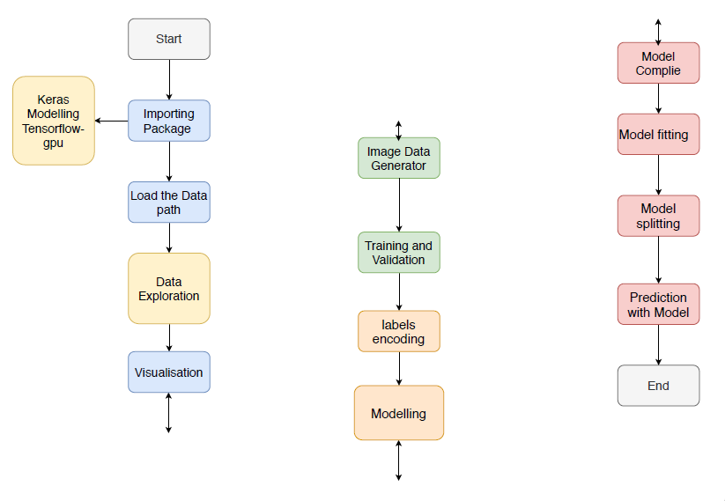

# 

# RESULTS AND DISCUSSIONS

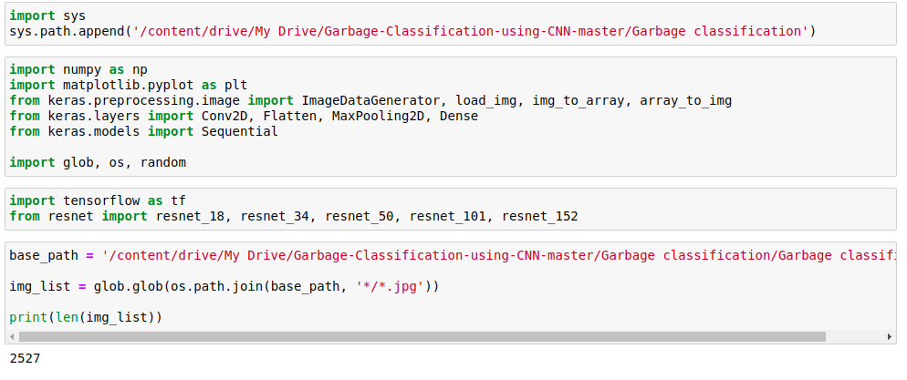

**Importing the package for analysis & classifying the garbage types**

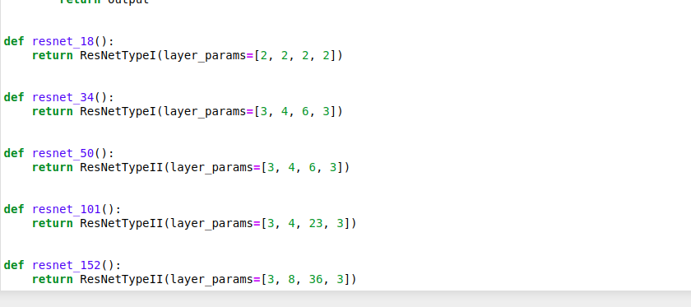

# 

# Model Architecture ResNET

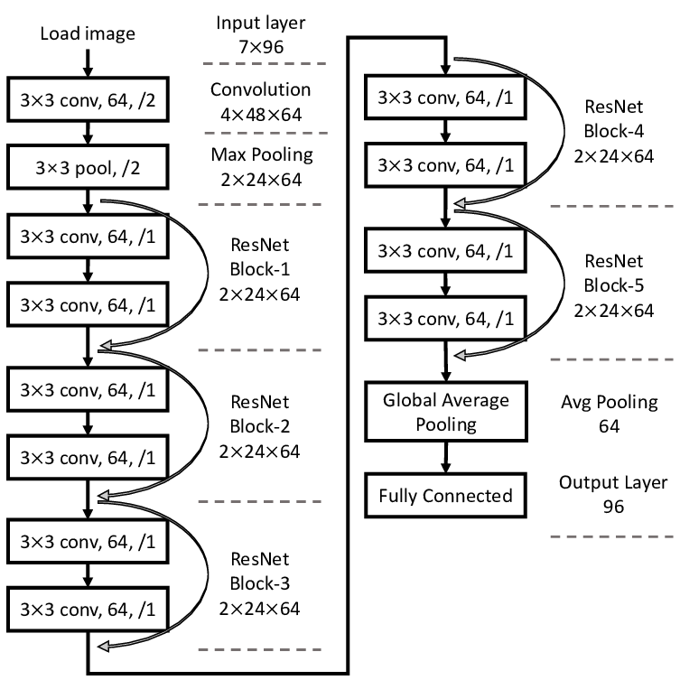

**Dataset folder path**

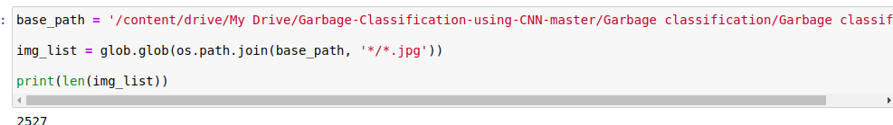

**Visualize the first 6 image from the path**

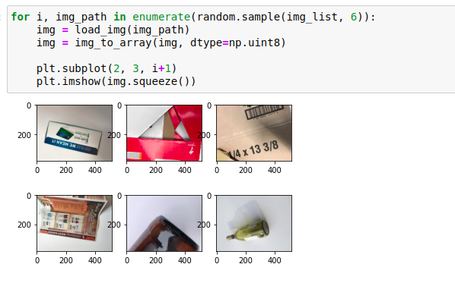

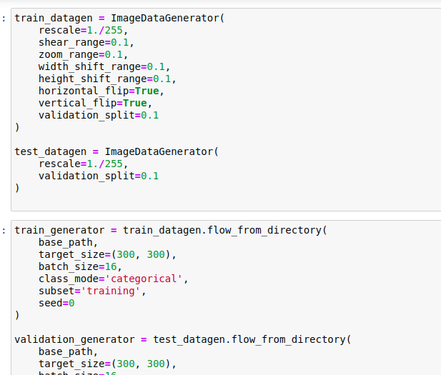

**Training the images based on the labels with splitting the data to train and test which result**

**Found 2276 images belonging to 6 classes.**

**Found 251 images belonging to 6 classes.**

**Neural Network Model**

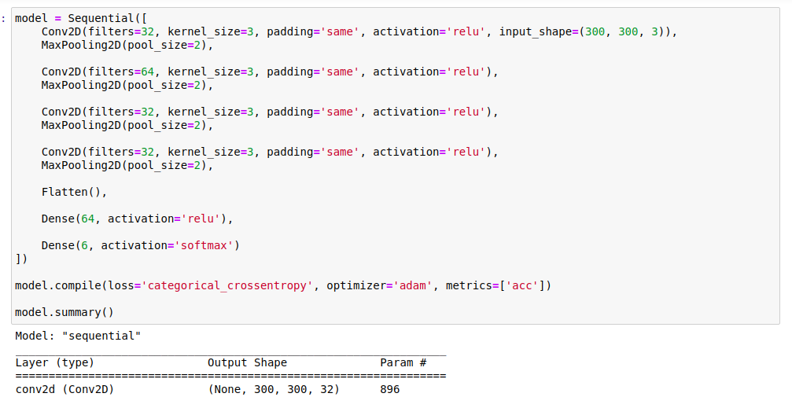

**Predicting based on NN**

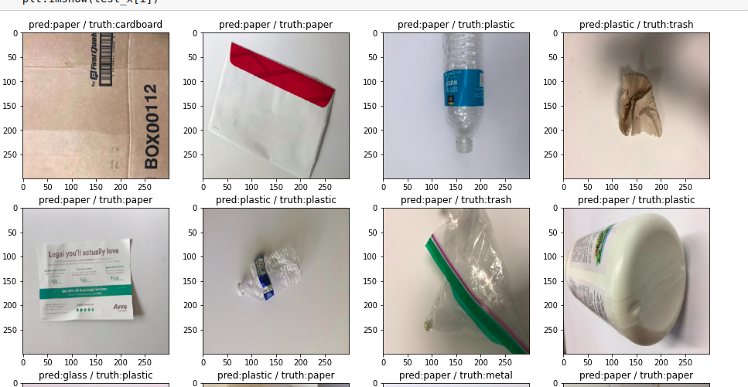

**Modelling with ResNET-50**

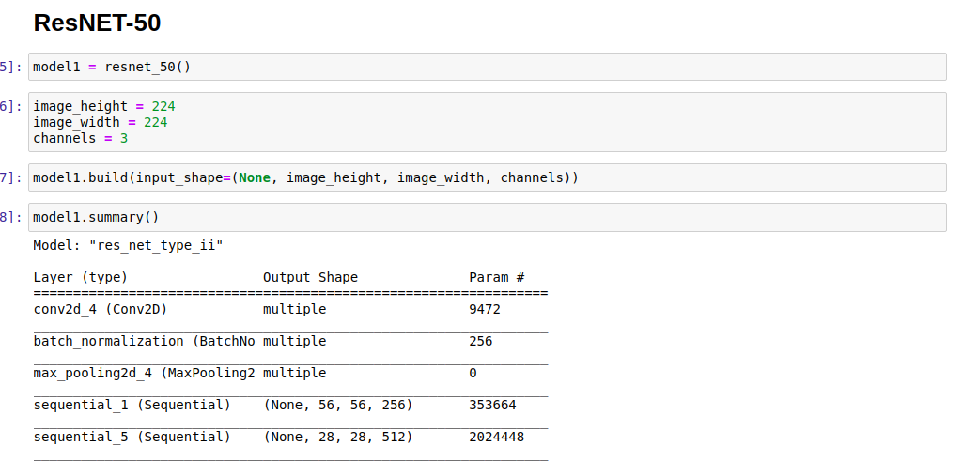

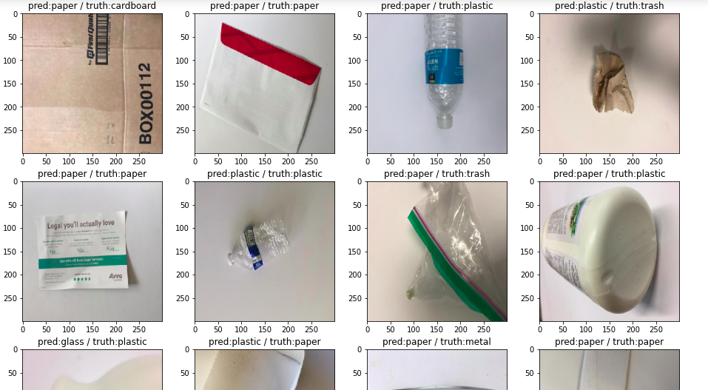

**Predicting based on ResNEt-50**

**Modelling based on ResNET-34**

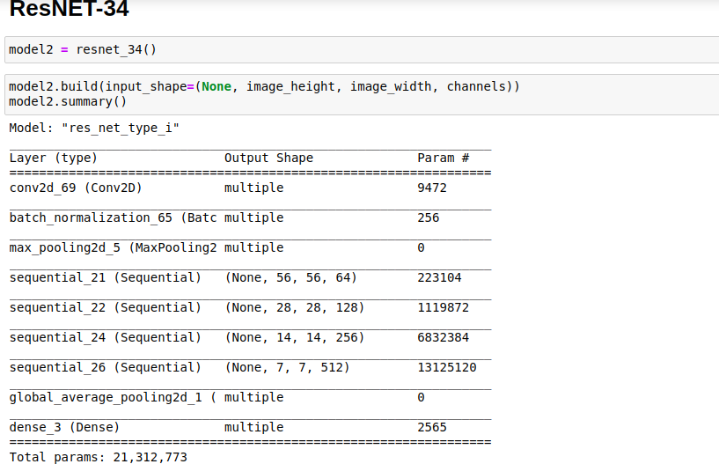

**Predicting based on ResNEt-34**

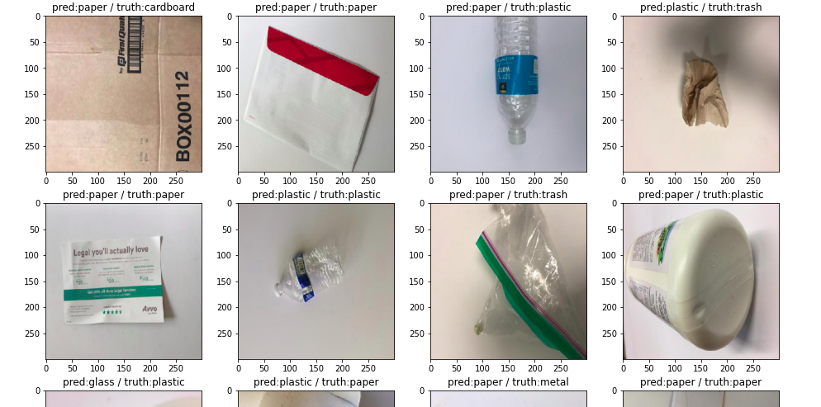

**CONCLUSION**

Aiming at the problem of garbage classification, this paper proposes an improved algorithm based on ResNet-34 and three tailor-made modi_cations, including the multi feature fusion, the feature reuse of residual unit, and optimization of activation function. Firstly, experiments on common data sets have been implemented to determine the basic model and ResNet-34 shows best performance and is chosen. Secondly, ResNet-34 are modi_ed to further improve the classification accuracy in three aspects. The modi_cations are tested on the garbage data set with 14 types of garbage. The accuracy of original ResNet-34 is 0.985 9. The accuracy of ResNet-34-A using multi feature fusion is increased to 0.994 1. The accuracy of ResNet-34-B using residual unit is improved to 0.999 5. And the accuracy of ResNet-34-C using modi_ed activation function is increased to 0.992 8. And ResNet-34- ALL which combines all three modi_cations has the highest accuracy of 0.999 6. Finally, an automatic garbage classi-_cation system is integrated with the proposed algorithm

and necessary hardware, and the system is effective with the classification accuracy as high as 0.999 6 and stable with the classification cycle as quick as 0.95 seconds on average.

**FUTURE SCOPE**

there are still some problems worthy of further exploration. Firstly, the classification of small target is not well and can be improved in future. Secondly, the classification criteria can be further extended, such as kitchen waste.

**8.BIBILOGRAPHY**

[1] J.-J. Wang, N.-N. Zhao, and J.-H. Li, ``Current situation of marine

microplastics pollution and prevention proposals in China,'' *China*

*Environ. Sci.*, vol. 39, no. 7, pp. 3056_3063, Jul. 2019, doi: 10.

19674/j.cnki.issn1000-6923.2019.0360.

[2] W.-B. Li, G. Ma, E.-Q. Yang, Y.-M. Cai, Z. Chen, R.-F. Gao, J.-H. Yan,

X.-F. Cao, and E.-J. Pan, ``Study on characteristics of electric dust removal

_y ash and bag _y ash in circulating _uidized bed waste incineration

system,'' *Proc. CSEE*, vol. 39, no. 5, pp. 1397_1405, Mar. 2019, doi: 10.

13334/j.0258-8013.pcsee.181110.

[3] D. Porshnov, V. Ozols, and M. Klavins, ``Thermogravimetric analysis as

express tool for quality assessment of refuse derived fuels used for pyro-

gasi_cation,'' *Environ. Technol.*, vol. 41, no. 1, pp. 35_39, Mar. 2020.

[4] P. Kellow, R. J. P. C. Joel, D. Ousmane, D. A. Kumar, D.-A. C. V. Hugo,

and K. A. Sergei, ``A smart waste management solution geared towards

citizens,'' *Sensors*, vol. 20, no. 8, pp. 1_15, Apr. 2020, doi: 10.

3390/s20082380.

[5] Y.-G. Cheng, N. Chen, and H. Zhang, ``Coal _y ash as an inducer to study

its application in the production of methane gas from domestic waste,''

*Fresenius Environ. Bull.*, vol. 29, no. 2, pp. 1082_1089, 2020.

[6] Y. Ren, J.-J. Yang, H.-J. Cao, Q.-Y. Zhang, and Q. Liu, ``All components

resourcing system of rural garbage based on post-gather automatic sorting

and disposal technology and its application,'' *Trans. Chin. Soc. Agricult.*

*Eng.*, vol. 35, no. 4, pp. 248_254, Feb. 2019, doi: 10.11975/j.issn.1002-

6819.2019.04.031.

[7] D.-E. Zhao, R. Wu, B.-G. Zhao, and Y.-Y. Chen, ``Research on garbage

classi_cation and recognition on hyperspectral imaging technology,'' *Spec-*

*trosc. Spectral Anal.*, vol. 39, no. 3, pp. 921_926, 2019.

[8] T. Kano, E. Naito, and T. Aoshima, ``Decentralized control for swarm

robots that can effectively execute spatially distributed tasks,'' *Artif. Life*,

vol. 26, pp. 243_260, Apr. 2020, doi: 10.1162/artl_a_00317.

[9] W. Pereira, S. Parulekar, S. Phaltankar, and V. Kamble, ``Smart bin (waste

segregation and optimisation),'' in *Proc. Amity Int. Conf. Artif. Intell.*

*(AICAI)*, Dubai, United Arab Emirates, Feb. 2019, pp. 274_279.

[10] K. He, X. Zhang, S. Ren, and J. Sun, ``Deep residual learning for image

recognition,'' in *Proc. CVPR*, Dec. 2015, pp. 770_778. [Online].Available:

http://arxiv.org/abs/1512.03385